The Contractor App is our new feature, currently in beta testing, which enables your contractors to update maintenance directly. This can save you time emailing contractors, downloading invoices to upload to agentOS etc as your contractors can update online.

You will need to ensure your Contractor is set up on the system and the email address they use to correspond with you is on their account information.

For your contractor to access the app, they will need to access the following link - https://contractor.agentos.com/
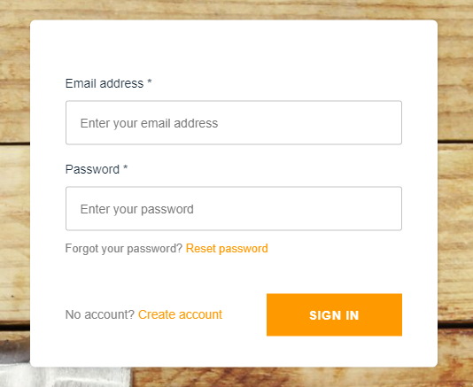
On the login screen, your contractor will see the following screen. For the first time accessing the account they will need to click the ‘Create Account’ icon.

This will take them to a new screen that will allow them to fill in their email address(the same as you hold for them) and a desired password to access the account and ‘Create Account’. The contractor will then be issued a verification code via email to access their account for the first time.
Once this is received, the contractor can return to the login screen and input their email address and the password they set previously.
If the contractor is registered with multiple agencies – upon login in they will be taken to their Accounts page – here they will select the agency in question and the associated agencies job:
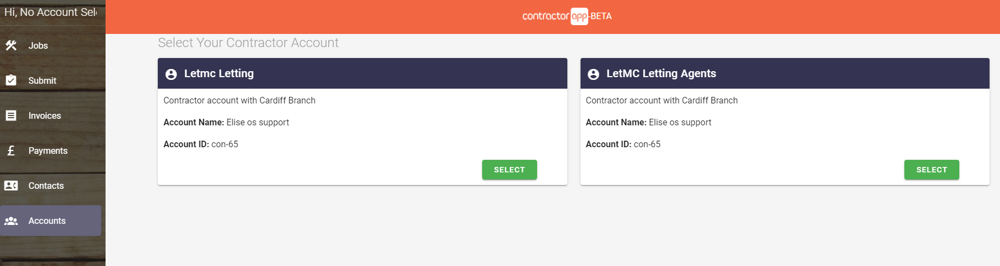

Upon selecting the account, they will be taken automatically to the ‘Jobs’ area on the left. Where they will see any jobs from the last 30 days that have been assigned.
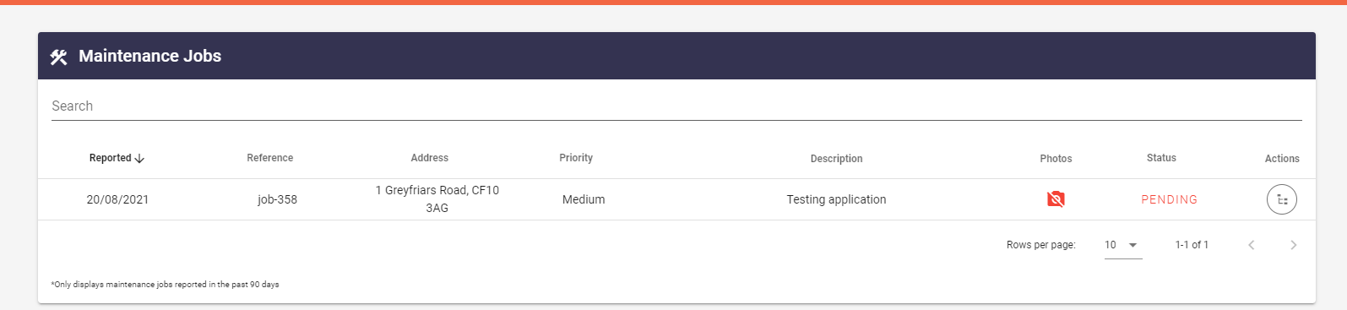
Within ‘Jobs’ they can see the property address and view any included photos that have been assigned, along with job priority.
Through the ‘Actions’ option on the far right on this page:
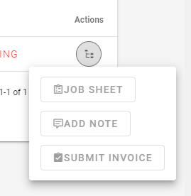

The contractor can either download the Job Sheet, Add a Note or Submit Invoice(These can also be submitted quickly under Invoices on the navigation ladder) for the job. If the contractor is submitting their invoice to indicate completion of the job – within this same page, they can update the status for themselves* by clicking the Status of Pending. The status will then update to Completed on the app.
Further down on the Navigation Ladder – the contractor will find ‘Payments’ and ‘Invoices’ which will allow them to see and download their latest submitted invoices and view their paid remittance notes/invoices. They will also be able to see their current account balance to get an idea of any payments that will be due to them soon.
Lastly, under Contacts on the left hand navigation ladder, they will find Contacts which will allow them to find a list of any contacts at they office should they need to be in touch to confirm how access has been arranged for example.

